**Assignment 06**

1. **What are escape characters, and how do you use them?**

**Ans: Escape characters in Python are special characters that are used to represent certain characters in a string that may be difficult or impossible to include directly. Escape characters are represented by a backslash (\) followed by a character or a sequence of characters.**

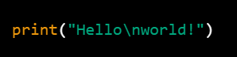 **>>>>>>** 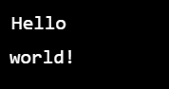

**>>>>>**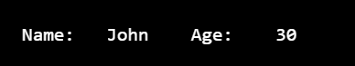

1. **What do the escape characters n and t stand for?**

**Ans:** **‘\n’ : A newline character is used to indicate the end of a line and start a new line in the output. It is commonly used when displaying text in separate lines, like in multiline strings or when printing a paragraph of text**

**‘\t’ :** **A tab character is used to create horizontal space between characters. It is often used to align columns of text or data in a visually appealing way**

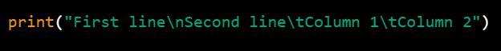

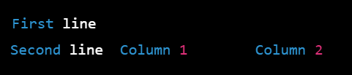

1. **What is the way to include backslash characters in a string?**

**Ans: In Python, to include a backslash character (\) in a string, you need to use an escape character \\ which represents a single backslash.**



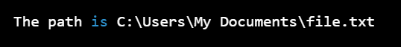

**4.** **The string “Howl’s Moving Castle” is a correct value. Why isn’t the single quote character in the word Howl’s not escaped a problem?**

**Ans:** **When you use double quotes to define a string in Python, any single quotes within the string are treated as regular characters and do not need to be escaped. Similarly, when you use single quotes to define a string, any double quotes within the string are treated as regular characters and do not need to be escaped**

**5.How do you write a string of newlines if you don’t want to use the n character?**

**6.** **What are the values of the given expressions?**

**‘Hello, world!’[1] >>>>>e**

**‘Hello, world!’[0:5]>>>>>Hello**

**‘Hello, world!’[:5]>>>>>Hello**

**‘Hello, world!’[3:]>>>>lo,world!**

**7.** **What are the values of the following expressions?**

**‘Hello’.upper()>>>>>>>>>>>HELLO**

**‘Hello’.upper().isupper()>>>>>>>> False (because ‘hello’ is not in upper and .isupper() returns Boolean value False)**

**‘Hello’.upper().lower()>>>>>>>hello**

**8.** **What are the values of the following expressions?**

**Question 🡪- ‘Remember, remember, the fifth of July.’.split()**

**Ans: [‘Remember’,’ remember’, ‘the’, ‘fifth’, ‘of’ ,’ July’]**

**Question🡪 ‘-‘.join(‘There can only one.’.split())**

**Ans: [‘There-can-only-one’]**

**9.** **What are the methods for right-justifying, left-justifying, and centering a string?**

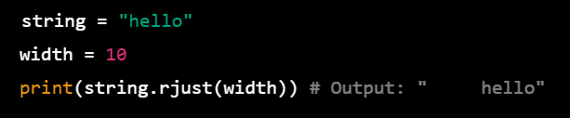-🡪**Right -justifying string**

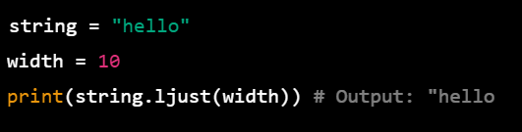**---🡪Left -justifying string**

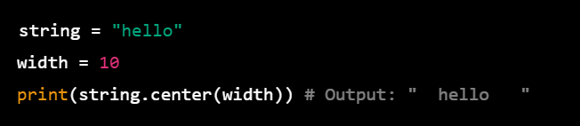**-----🡪Centering string**

**10.** **What is the best way to remove whitespace characters from the start or end?**

**Ans: Removing white spaces from start to end or end is strip() method**

**To remove whitespaces from start of the string >>>’lstrip()’**

**To remove whitespaces from end of the string >>>’rstrip()’**

**To remove whitespaces from both the start and end of string >>>’strip()’**

